# Node JS Exercise

## Steps

### Prerequisites

Create a GitHub account

Install <https://nodejs.org/en/>

Install Heroku CLI

### NodeJS App

<https://github.com/rohitbhardwaj/flow-demo>

$ git clone https://github.com/rohitbhardwaj/flow-demo.git

Cloning into 'flow-demo'...

remote: Enumerating objects: 45, done.

remote: Counting objects: 100% (45/45), done.

remote: Compressing objects: 100% (38/38), done.

remote: Total 45 (delta 12), reused 17 (delta 2), pack-reused 0

Unpacking objects: 100% (45/45), done.

$ ls

flow-demo heroku

$ cd flow-demo/

Rohits-MacBook-Pro:flow-demo rohitbhardwaj$ ls

Procfile app.json package.json test

README.md index.js public

### Visual Studio Code

$ npm install

$ npm start

[localhost:5000](http://localhost:5000/)

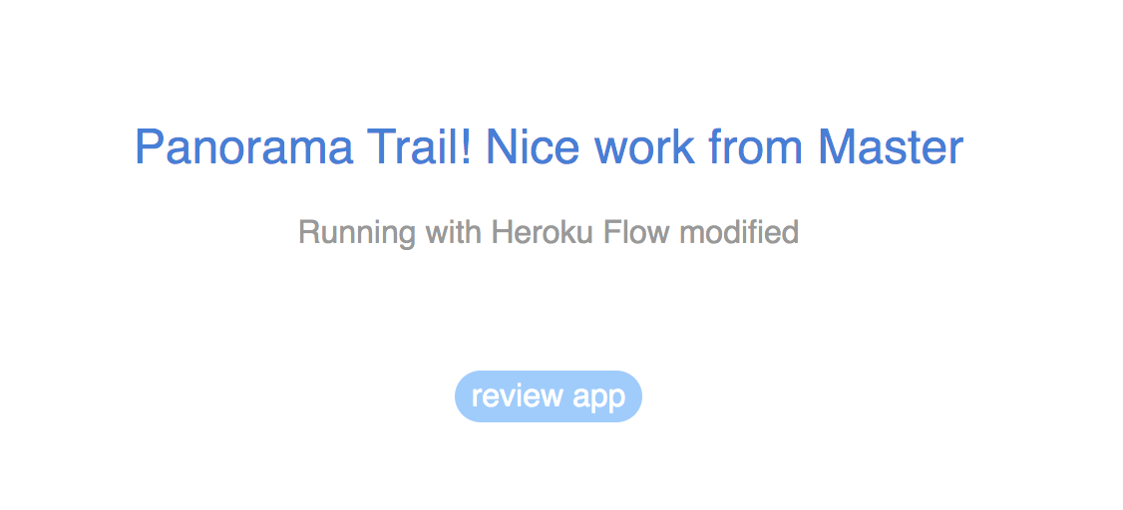

### Deploying to Heroku via CLI

$ heroku create

$ git push heroku master

$ heroku open

### Deploying using Heroku Command

